Git repo Project Claimed from- https://github.com/Vennilavanguvi/Trend.git

Forked GIT HUB repo
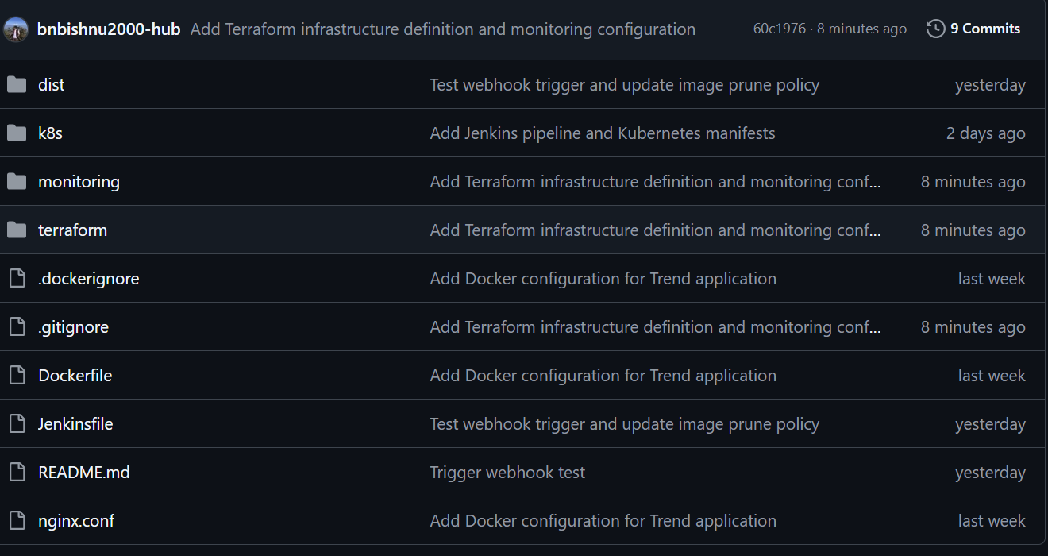

Dockerfile
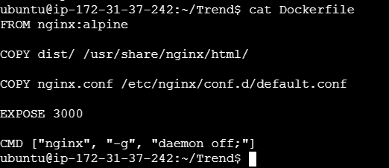
Build Dockerfile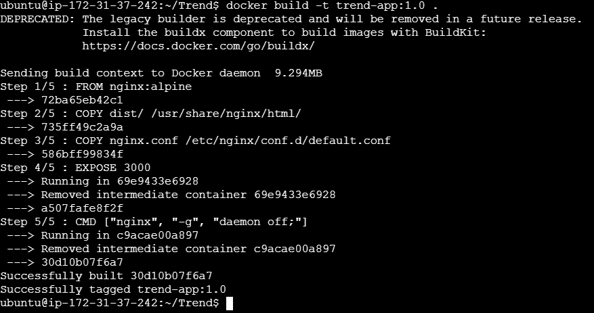

Dockerhub Repo
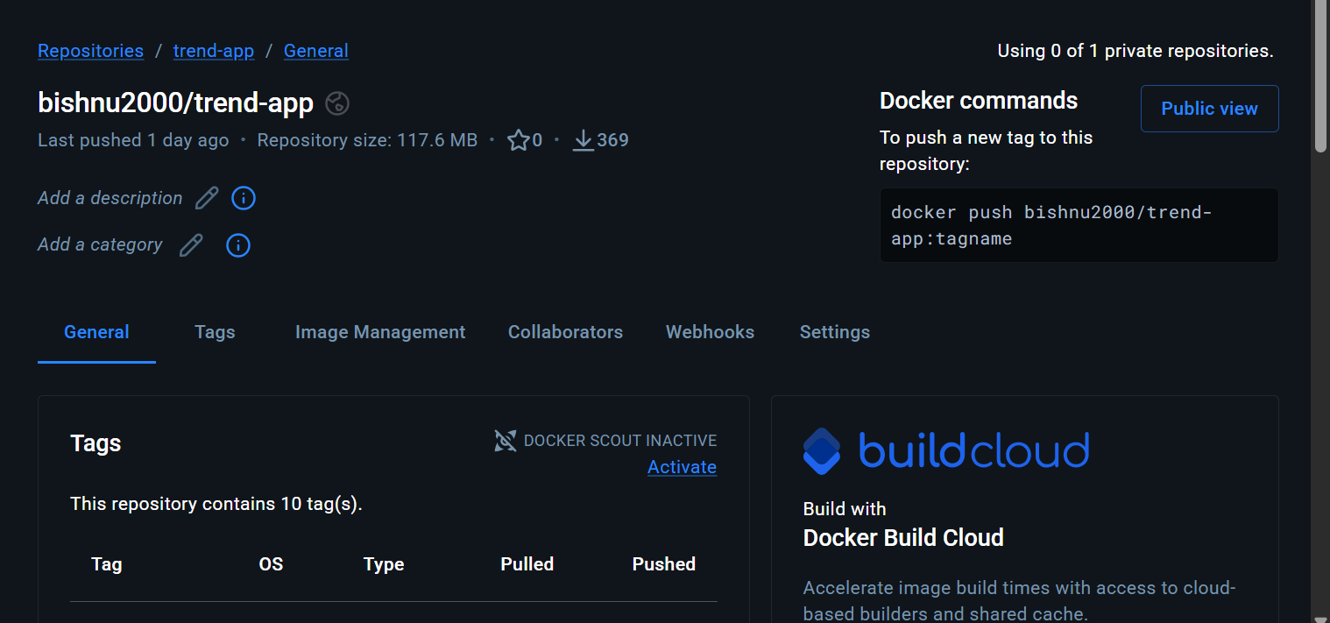
EKS Cluster
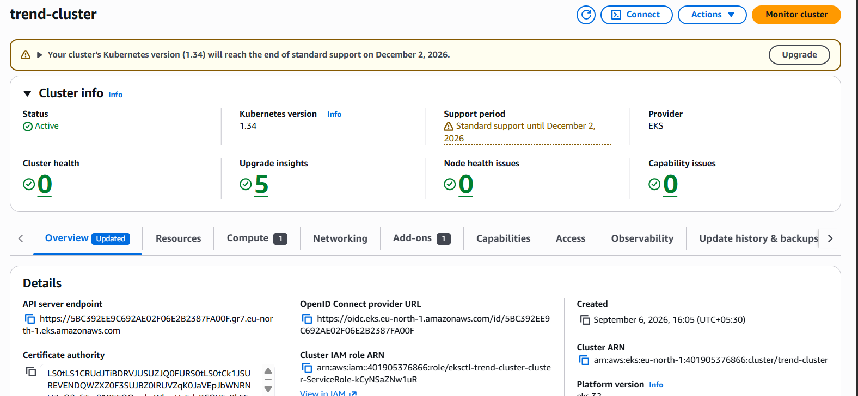
Node-Group
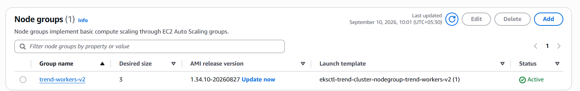
Kubernetes Deployment
Kubernetes Service
Application Running from AWS load balancer

On the requested ARN. The assignment asks for the LoadBalancer ARN. This could not be supplied, for a reason outside the configuration:
Error:
Warning SyncLoadBalancerFailed service-controller
Error syncing load balancer: failed to ensure load balancer:
error creating load balancer: "operation error Elastic Load Balancing v2:
CreateLoadBalancer, https response error StatusCode: 400,
OperationNotPermitted: This AWS account currently does not support
creating load balancers."

Jenkins
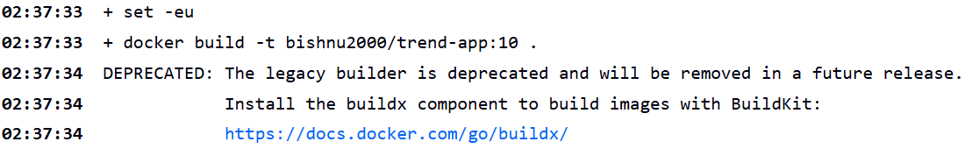
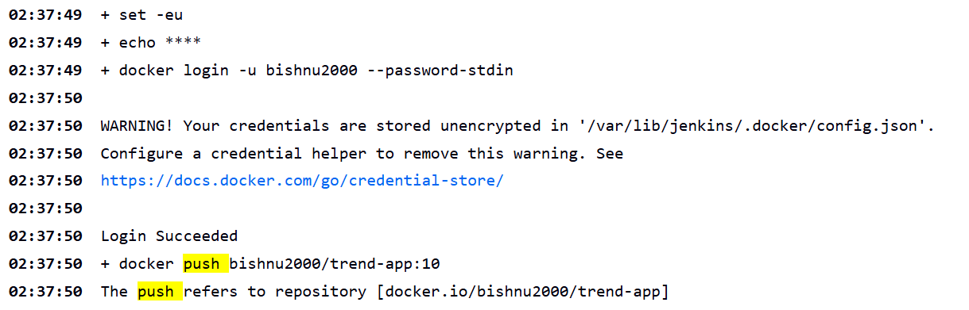
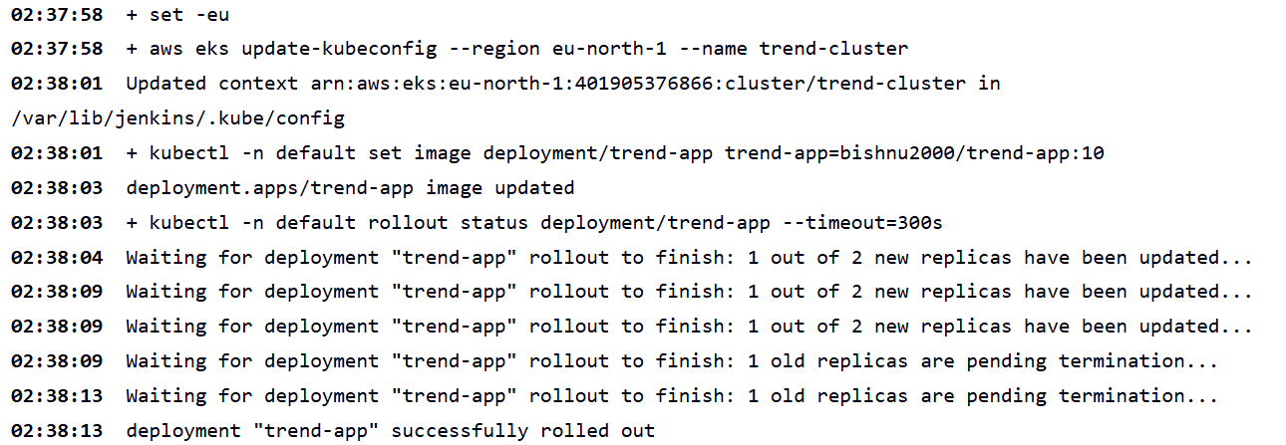
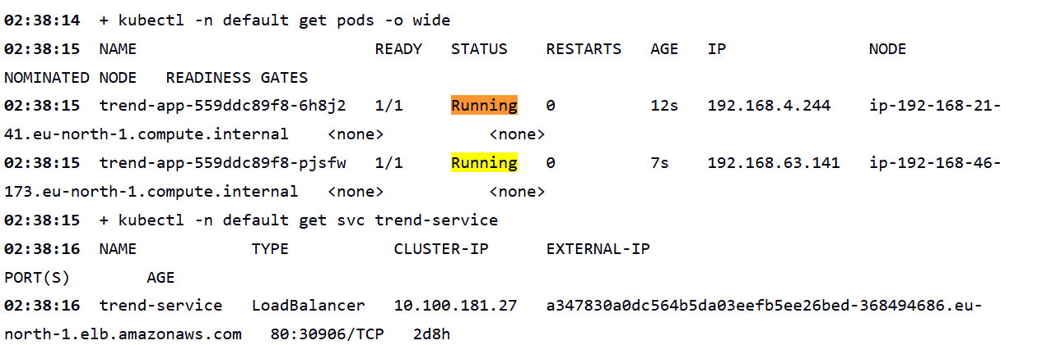
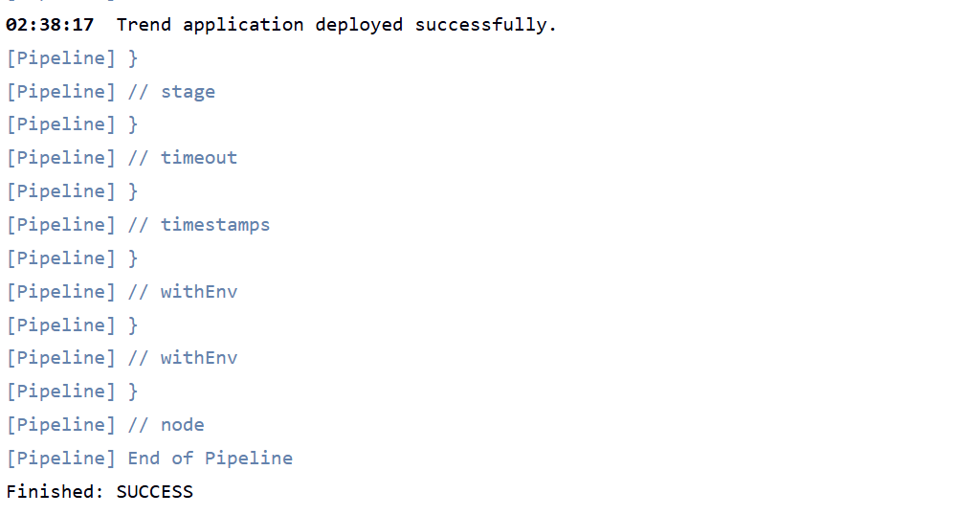

Stages

GitHUB webhook
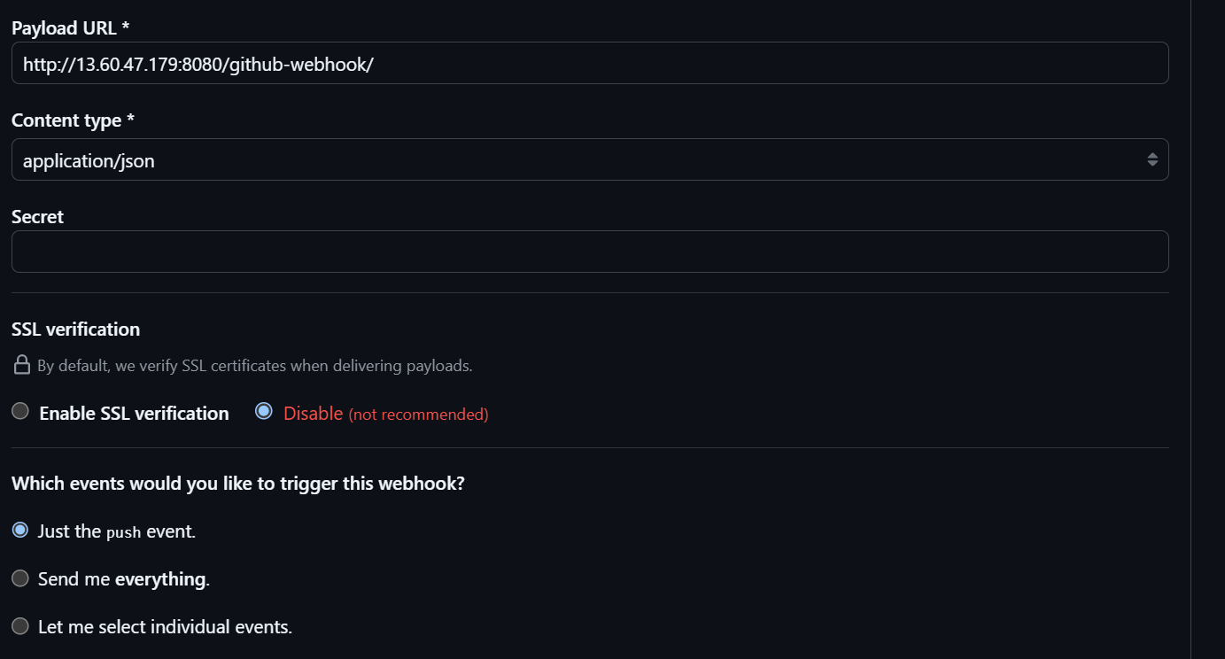

Grafana 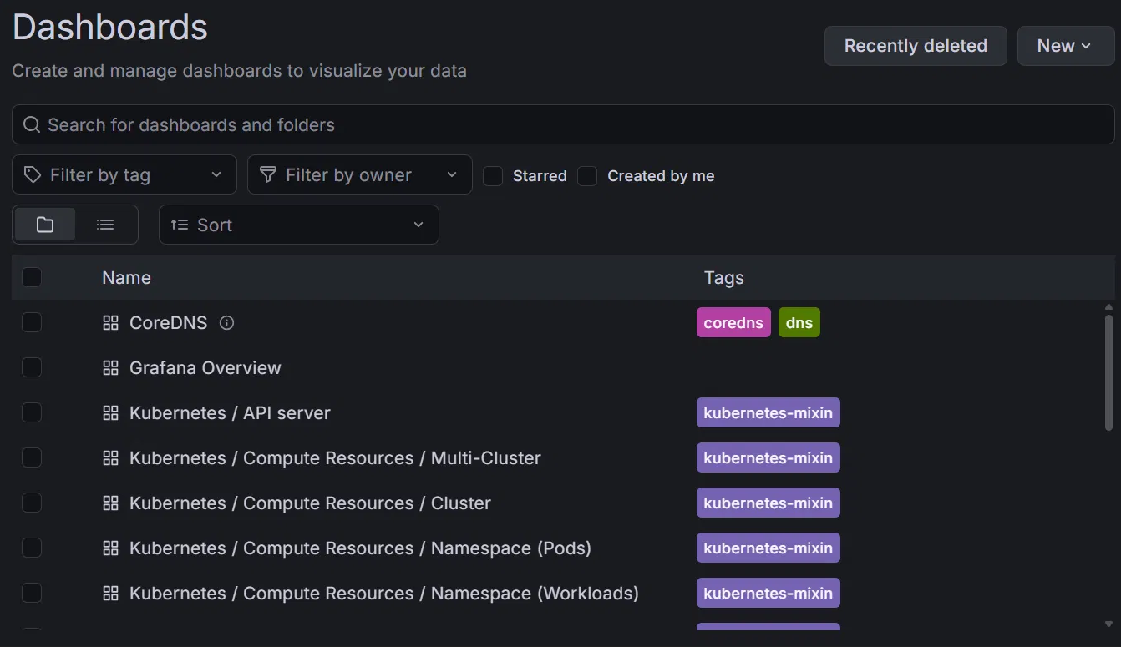
Prometheus
